Business Profile: ArtMareka
Business Name: ArtMareka
Industry: Visual Arts
Business Type: Creative Art Studio
Owner/Founder: Khatlako Mareka
Location: Online-based (ships locally and internationally)
Contact Info:
- Email: info@artmareka.com
- Phone: +266 57145220
- Instagram/Facebook: @ArtMareka

About ArtMareka
ArtMareka is a creative studio that specializes in handmade abstract paintings and custom pencil drawings tailored to your vision. Whether you're decorating your space or looking for a personalized gift, ArtMareka turns artistic expression into timeless visual statements.

Product Categories & Pricing

🎨 Abstract Paintings (Acrylic on Canvas)
Available in vibrant colors, bold textures, and unique styles. Custom sizes accepted.
Size Category | Dimensions (inches) | Price (USD)
Small | 8 x 10 to 12 x 16 | $25 – $40
Medium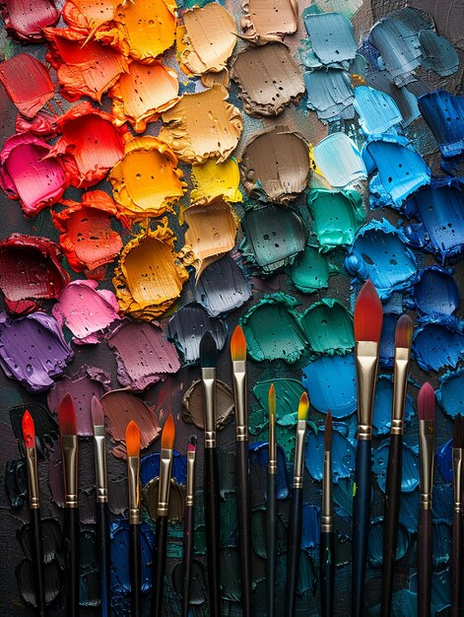 | 16 x 20 to 18 x 24 | $60 – $90
Large | 24 x 36 to 30 x 40 | $120 – $180
Extra-Large (Custom) | 36 x 48 and above | $200+
Customization (Color palette or theme request): +$10 – $30 depending on complexity
Framing: Optional, quoted separately

✏️ Custom Pencil Drawings (Black & White Realism or Stylized)
Drawings are made from high-quality references (photos or concepts provided by clients).
Size Category | Dimensions (inches) | Price (USD)
A5 (Small Portrait) | 5.8 x 8.3 | $15
A4 | 8.3 x 11.7 | $30
A3 | 11.7 x 16.5 | $50
A2 | 16.5 x 23.4 | $80
A1 or Custom Size | 23.4 x 33.1 | $120+
Additional Person or Object in Drawing: +$10 – $25
Color Pencil Upgrade: +$20
Delivery Time: 3–7 days (depending on size and complexity)

Shipping & Delivery
- Local Orders (Lesotho/South Africa): $5 – $10
- International Shipping: Calculated at checkout or via quote
- Pickup Option: Available for local customers

How to Order
- Visit our social media pages or contact us directly via email or phone.
- For custom pencil drawings, send your image and size preference.
- Receive a quotation and estimated completion time.
- Pay a 50% deposit to start your order.
- Remaining balance due upon delivery or before shipment.

Why Choose ArtMareka?
- Handcrafted, original artwork
- Attention to detail in every piece
- Customization for your unique taste
- Professional communication and service

